Module 2: Critical Thinking Assignment

Nathan Rogers
Colorado State University Global
Course Code: CSC505
Dr. Luis Gonzalez
02/23/2025

Assignment
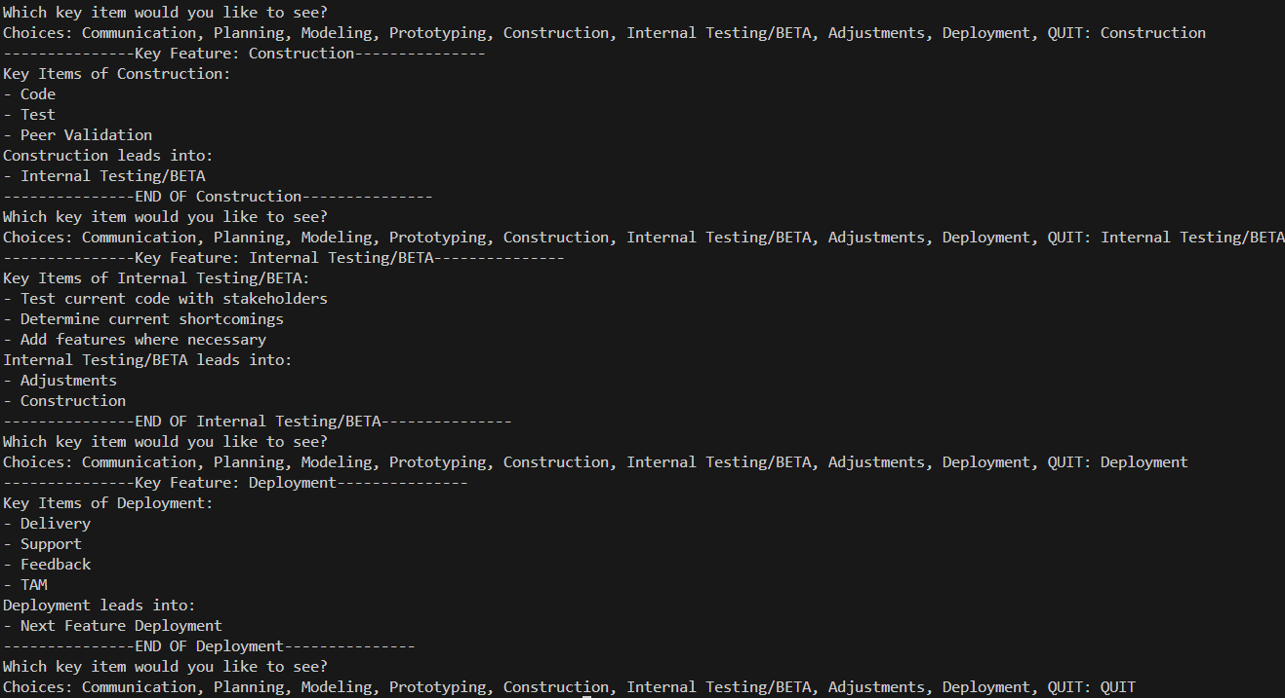
Implement the Rogers_Model class using Python, which will prompt the user to input the key elements of the diagram and return these objects in a well-formatted output. Below are the outputs from a select few choices to demonstrate the output you would get as a user:

Based on this modified waterfall diagram (Red lines indicate changes to the original waterfall diagram):
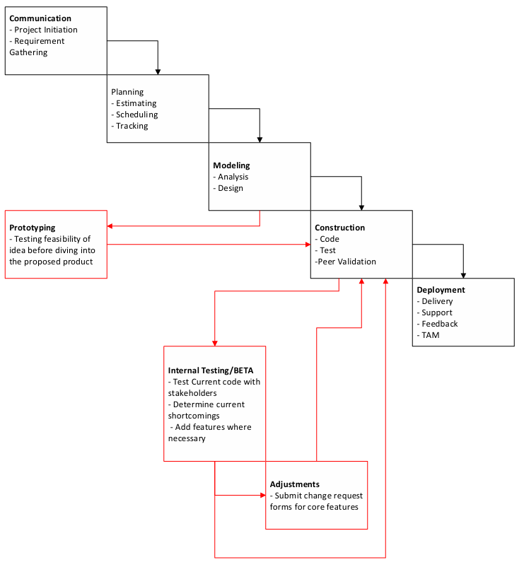

Evaluation of the Waterfall Model
While the waterfall model does have its advantages, such as using a clear structure and determining the end goal early, the waterfall model does have strong weaknesses too. Using the model outlined above, we can modify the existing waterfall model and tweak elements to make the model more useful in 21st century software engineering environments.
Waterfall Model Advantages
The waterfall model goes hand-in-hand with the predictive planning methodology. Clear and concise goals are defined from the start with a well-developed scope and procedure. For small projects, this may be more advantageous than using the agile methodology. I personally have had success with this methodology as the stakeholders I work with expect a clear and hard budget to be agreed upon before starting development. Gantt charts help integrate the waterfall model during the development process to keep everyone aligned on time sensitive goals ensuring the end goal and timeline are kept on track. Even when bringing on new people, the waterfall model/Gantt chart, a well-defined scope, technical specification, and outlined goals will help get the new developer or stakeholder up to speed quickly and without many issues.
Waterfall Model Drawbacks
In medium to large projects and complex goals, the waterfall model will fall short compared to other methodologies or models. The biggest drawback is the lack of flexibility with changes. Changes occur often during software development and can be caused by changes in the market, stakeholder requirements, or available budget. If the current model being followed is the waterfall model and a change needs to be made, it will be quite difficult to pivot in a new direction to address the change. This change can cause issues with the overall timeline, budget or goals that were rigidly set at the beginning of project during the planning process. One of the biggest drawbacks of the waterfall model is completing testing after the completion of the software construction. Testing this late in the process will only add delays to the completion of the project as anything that needs to be changed or fixed happens after everything is already put together. Addressing anything in this stage is very difficult as fixing certain features may break other features which once again increases the timeline, overall budget and completion date.
Addressing the first change suggested in the diagram above is adding a prototyping phase before construction of the code. Prototyping is such a valuable stage as it provides early feedback from stakeholders and end users before true programming begins. Prototyping also allows for testing the feasibility of the project in the current market. If the prototype produced doesn’t quite fit the initial design or doesn’t have a want/need in the current market, then the time and money invested isn’t sufficiently warranted. The company and development team can then invest time and money in a project that has a place in the market to be profitable.
Looking at the second addition to the original waterfall model, internal testing/BETA testing and adjustment steps are added after construction. This step is also important before the release of the software for several reasons. The biggest reason is to find bugs within the code that have slipped through the debugging portion of construction. Releasing buggy and unfinished software will not only turn people away from purchasing or using the software but this will also affect the credibility of the company in the software space. Having a Construction -> Internal testing -> Refinement -> Construction loop is incredibly useful during software development. Refinement of features and discovery of bugs during the construction phase can help ensure smooth corrections and adjustments from introducing feedback from users earlier in the process.

References
Pressman, R. S., & Maxim, B. R. (2020). Software engineering: A practitioner’s approach. McGraw-Hill Education.
Whitson, G. M. (2022). Software Engineering. Salem Press Encyclopedia of Science.
Lishner, I. (2023). Enhancing Strategic Planning of Projects: Selecting the Right Product Development Methodology. MDPI, 14(12), 632–654.
The Pros and cons of waterfall methodology. Lucidchart. (2018, August 10). https://www.lucidchart.com/blog/pros-and-cons-of-waterfall-methodology
Raymond, D. (2023, October 29). Top 10 cons or disadvantages of using Waterfall methodology. ProjectManagers.net. https://projectmanagers.net/top-10-cons-or-disadvantages-of-using-waterfall-methodology/

